Consultation concerning provision of caretaking at Ashworth Mansions.

Dear Flat Owner

I’d like to update you about options for caretaking at Ashworth Mansions. We are considering a number of options and would like your views.

As you know, the estate has always benefited from a live-in caretaker. The most recent incumbent, Daron Tyas, resigned from his position on 1st May 2013. Since then, we’ve had only a part time temporary agency caretaker from 8am to 1pm each day who has been undertaking general sweeping, checking drains, collecting rubbish, issuing fobs and other general duties as and when required.

There are three main options.

- • Employ a live in caretaker as before (8-4 weekdays, 8 -12 Saturday) – cost £58K pa
- • Employ a non-live in caretaker with extended hours (7-5 weekdays, 8 – 12 Saturday) to also include cleaning the common parts which is currently done by a contract cleaning company – cost £29K pa
- • Enhance the service to include a staffed estate office from 7am and 8pm Monday to Friday and 8am to 2 pm on a Saturday. This office would be near the boiler room and available to residents for parcels and key management – cost £67K

Other combinations of staffing and hours are possible but, for simplicity, I wanted to give you a sense of the costs of various options. In addition, it would probably cost £20-£30K to build an estate office but we could fund this from accumulated ground rents in Ashworth Mansions Ltd. This wouldn’t be a service charge item.

Yours faithfully

Geoffrey Barraclough
Chair, Ashworth Mansions Ltd

Survey response

15 responses + 6 sent by email = 21.
2 responses were from owners of 2 flats so 23 of the 104 flats are accounted for.

Flat Owner

44 Geoffrey Barraclough
49 Syona and Reto Munz
48 Dina Teitler
80 Nick & Angela Parker
27 Sanjay Tanna
1 Ivan Stuart
76 Preethi Reddy
29a Keith & Vanessa
15 Joanna Dineraki
50 Marianna & Alfonso Gonzalez
38 Simon Allen & Julia Murray
70/72 Martin and Maryam Clements
58 John Sutcliffe
67 Gavin Pommernelle
28 Susan Johnson
6a Peyron Law
73 Jemma Clee
53 Niall Campbell and Marion Burmester-Campbell
41 Simon & Katya Gamlin
82/83 Julian Browning
? Pamela Knudson

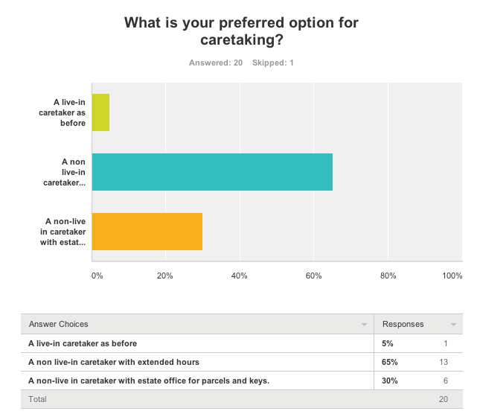

Note: the one response recorded as having skipped this question was in favour of option 2. One response for option 3 asked for this combined with a live- in caretaker.

Comments

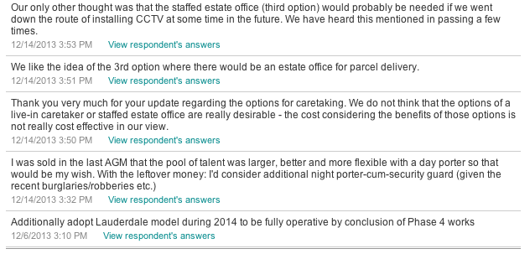

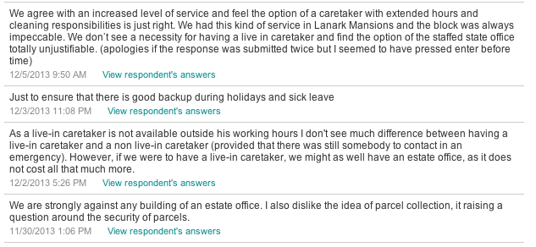

GB 14/12/13

